26. Develop a system using UML for Jewellery Shop Management System. The admin can add new customer detail and update the existing customer’s detail. Whenever a customer made a purchase, it should reflect in the bill details as well as in the customer details. Also, the system should update the stock remained the shop.

ACTIVITY DIAGRAM:

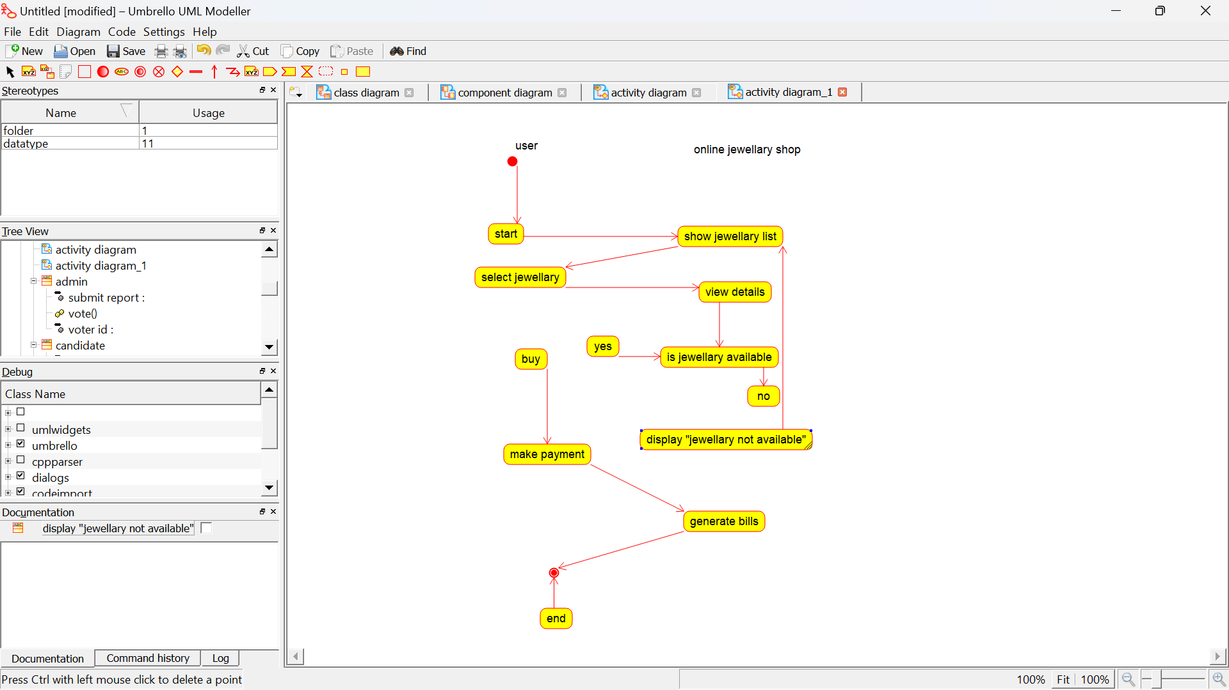

USECASE DIAGRAM:

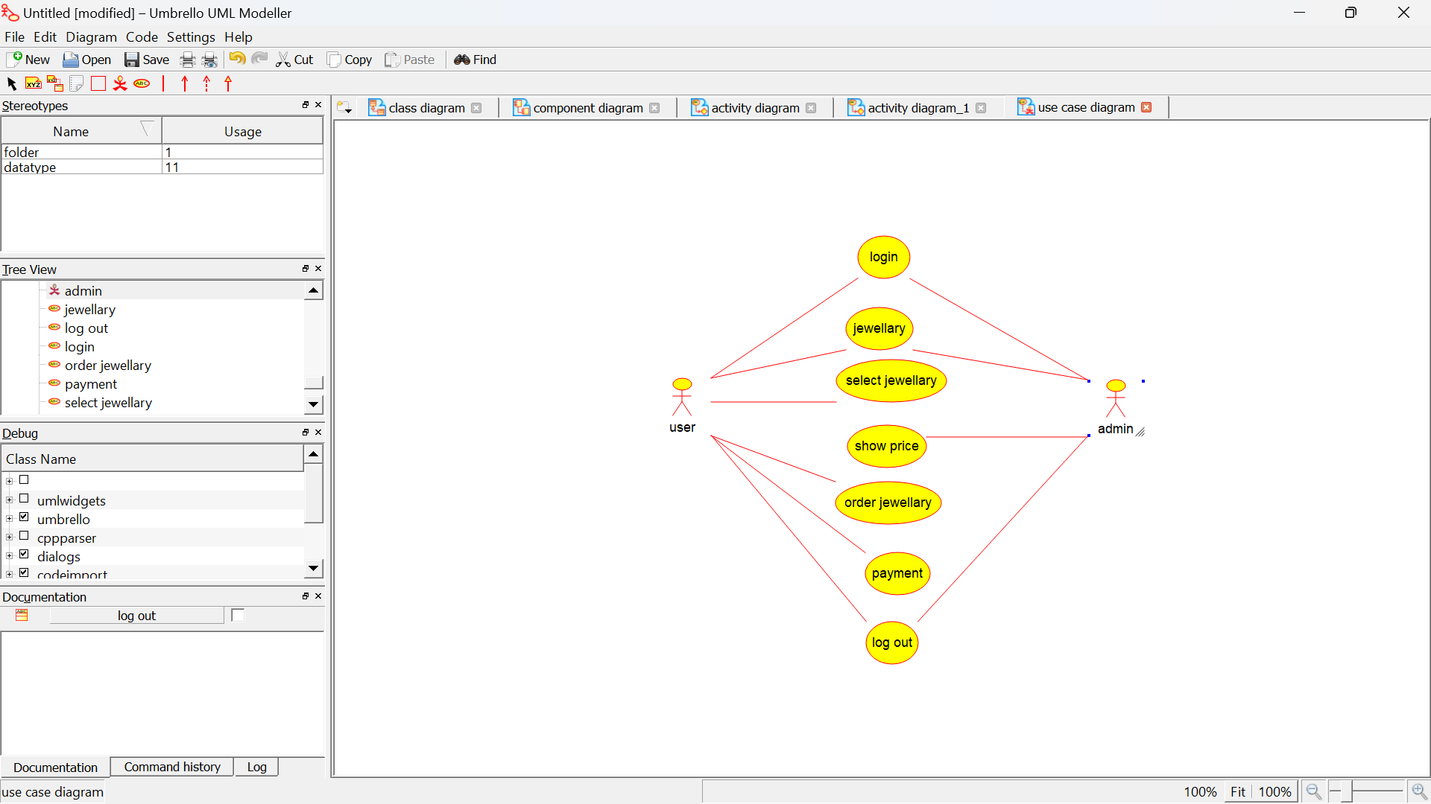

COMPONENT DIAGRAM:

